Using Existing CCTV Network for Crowd Management, Crime Prevention & Work Monitoring using AI & ML

In this project you are asking to manage crowd using advance AI and ML algorithms so we are implementing YOLO8 algorithm which is more advance than any other algorithms exists today. This algorithm will detect only available peoples in the current frame of CCTV footage and then count them, if number of crowd increases then there is a chance of crime and system will alert authorities to take necessary action.

In existing technique manual human efforts required to monitor crowd in the public area but propose algorithm will detect all moving persons and then count them as crowd.

This application will work on any CCTV videos where moving crowds exists.

To implement this project we have designed following modules

1. Generate & Load YoloV8 Model: using this model will load Yolov8 algorithm to application
2. Crowd Management from Images: this module can detect crowd from images
3. Crowd Management from Videos: this module can detect crowd from current playing video frame
4. YoloV8 Training Graph: will plot Yolov8 training performance graphs of precision, recall etc.

SCREEN SHOTS

To run project double click on run.bat file to get below screen

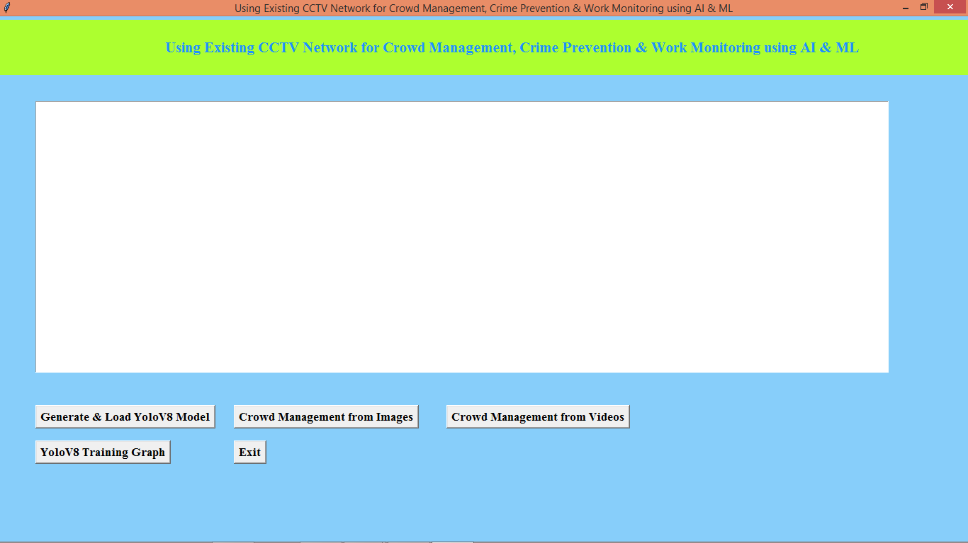

In above screen click on ‘Generate & Load YoloV8 Model’ button to load Yolo8 algorithm and get below page

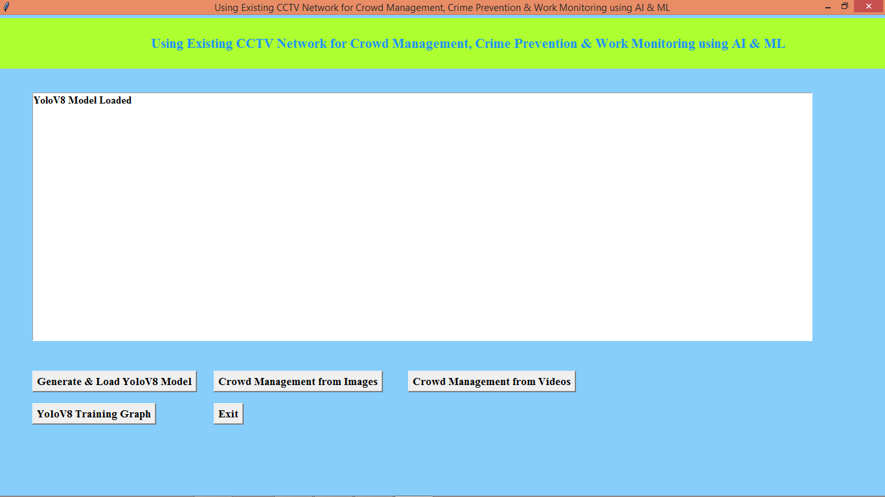

In above screen model loaded and now click on ‘Crowd Management from Images’ button to upload image and get output

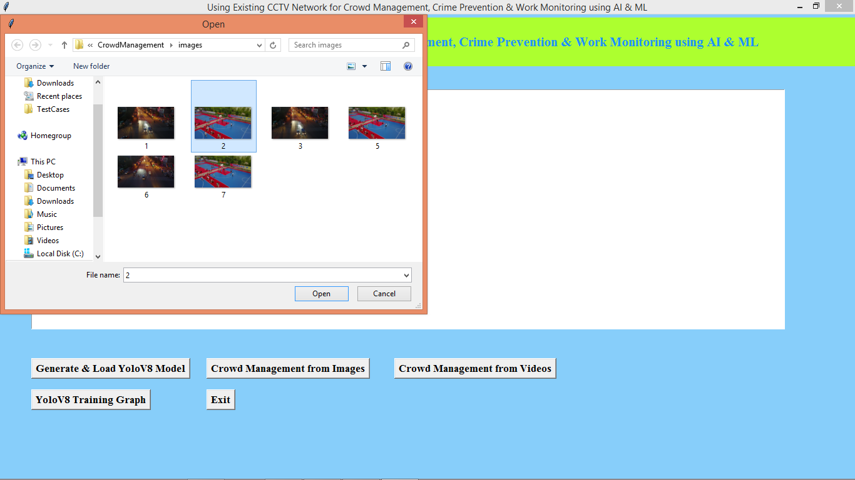

In above screen selecting and uploading image and then click on ‘Open’ button to get below output

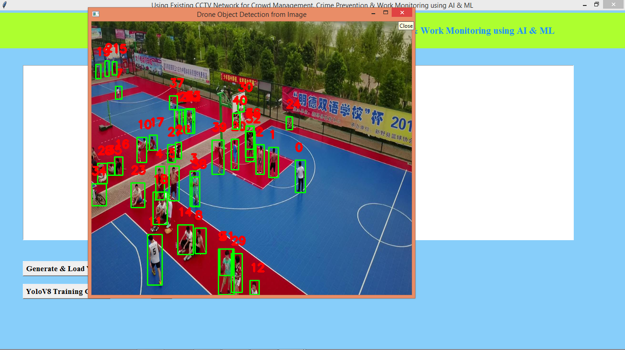

In above screen can see all detected crowd objects and then each crowd person is marked with their appearance count and similarly you can upload video also

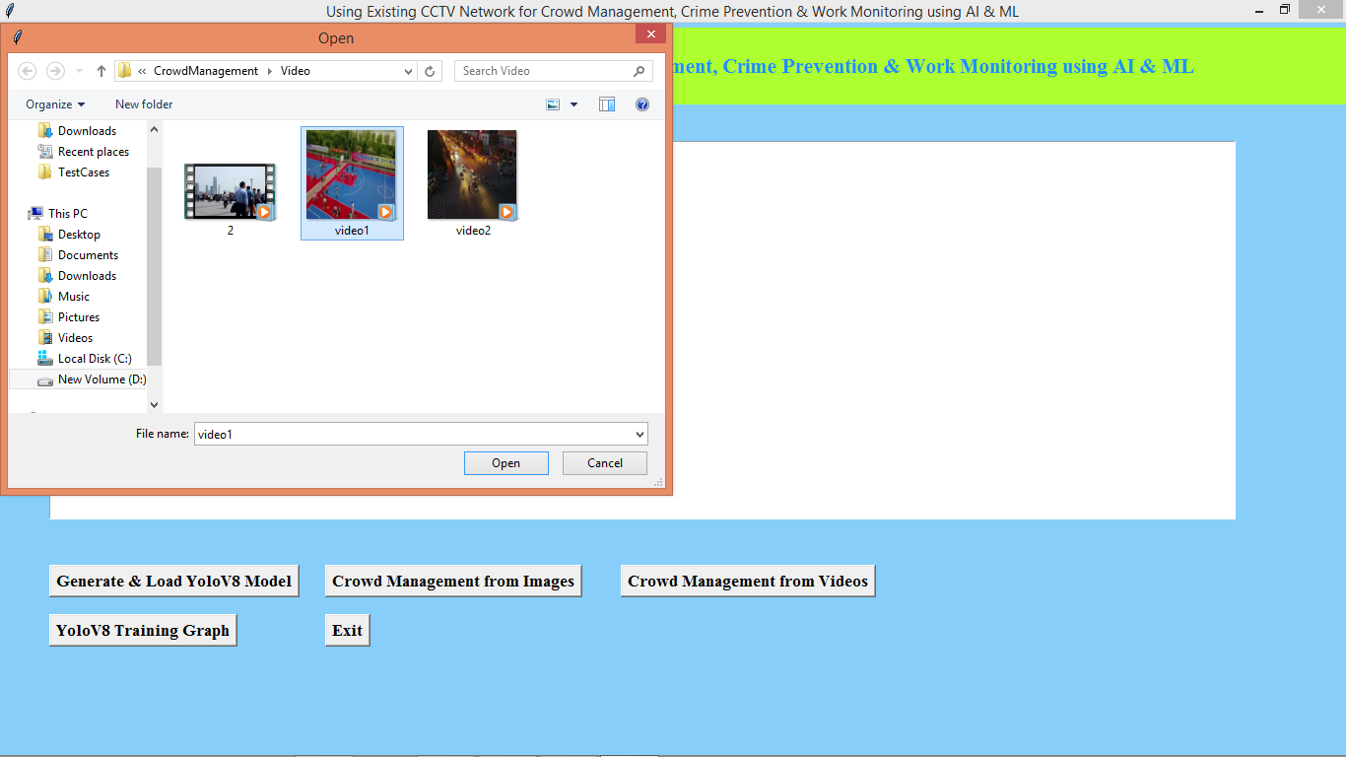

In above screen selecting and uploading video file and then click on ‘Open’ button to get below output

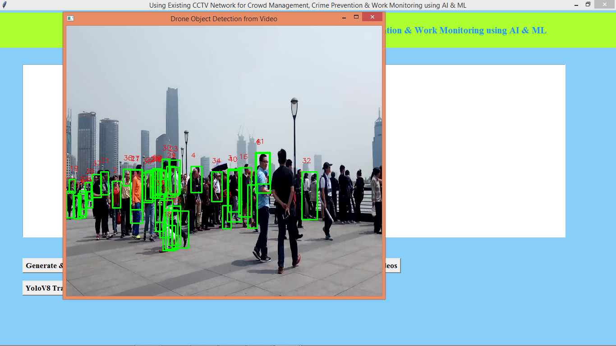

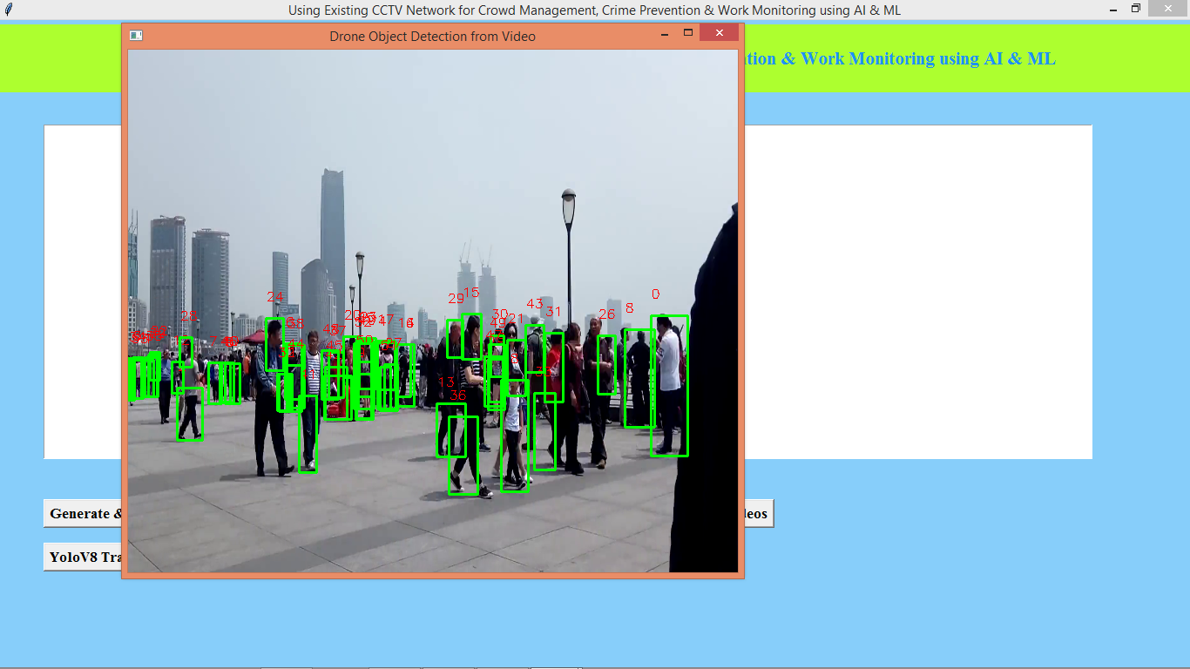

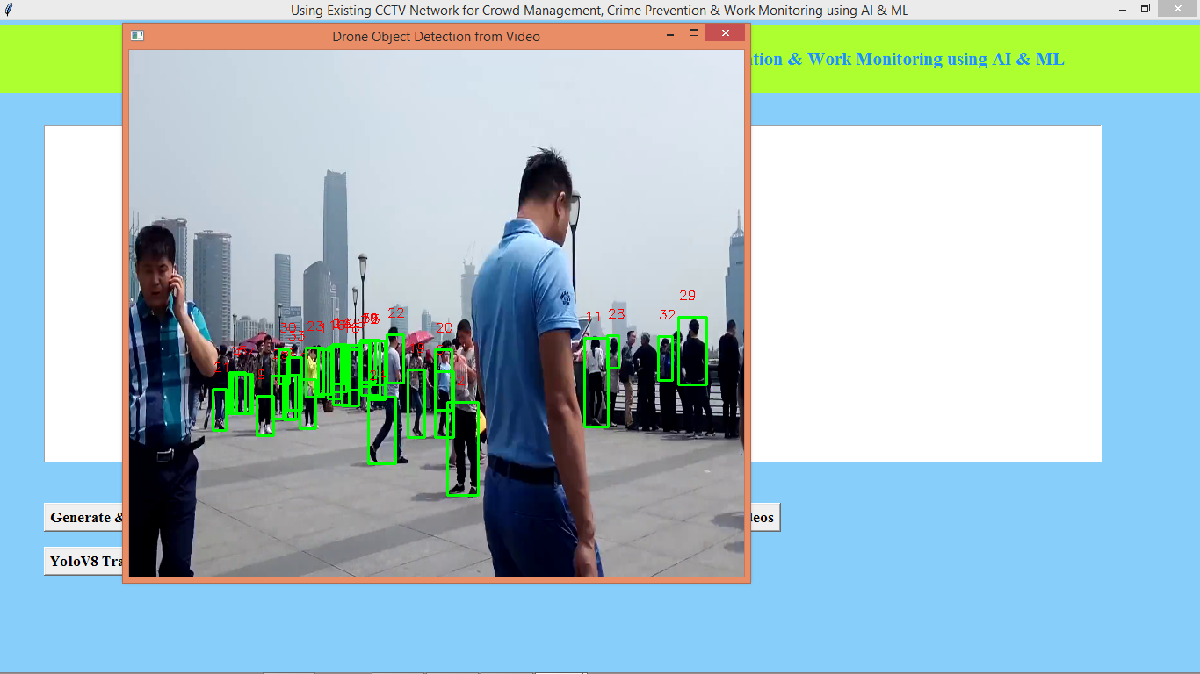

In above playing video we can see all detected crowd peoples and then in red colour we can see current frame crowd count and similarly you can upload and test videos of any moving crowds. Now click on ‘YoloV8 Training Graph’ button to get below graph

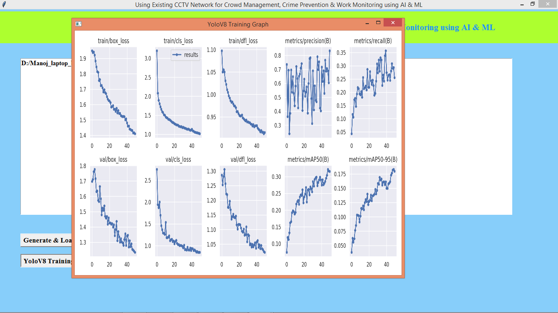

In above graph x-axis represents training epochs from 0 to 40 and y-axis represents Recall, Precision and loss in different graphs. In above graphs we can see loss values continuously decrease with each training epoch and reached closer to 0 and precision, recall continuously increase with each epoch and reached closer to 1.